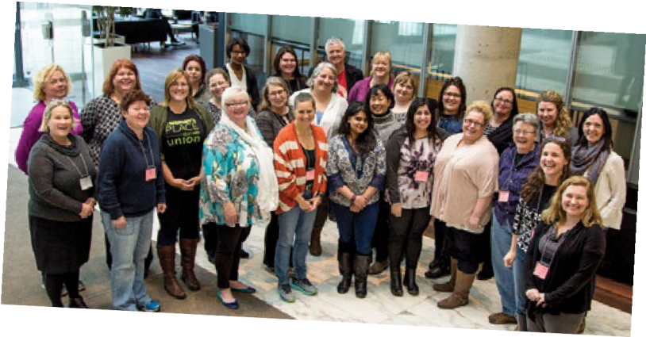
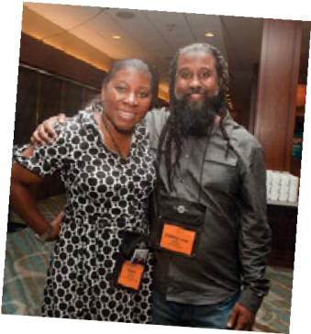
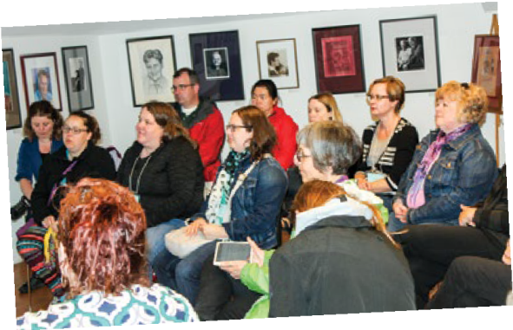
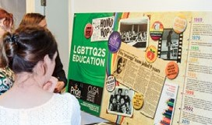
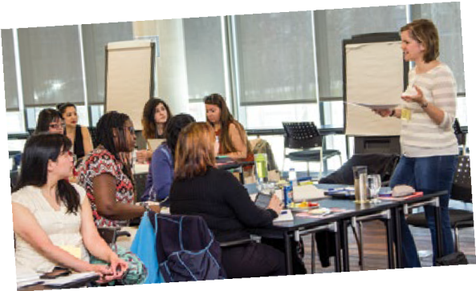
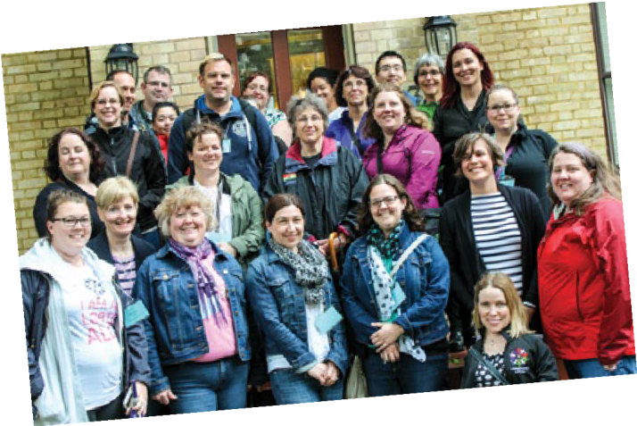
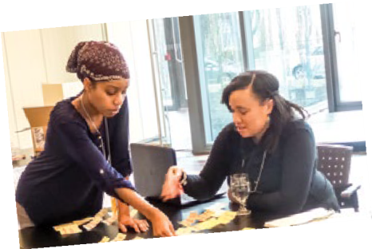
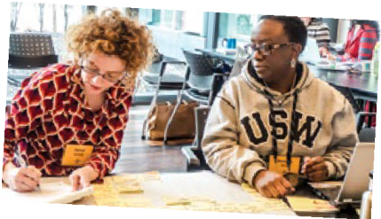
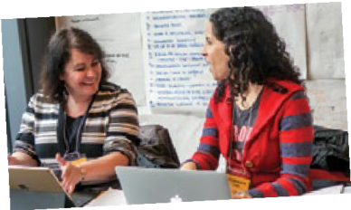
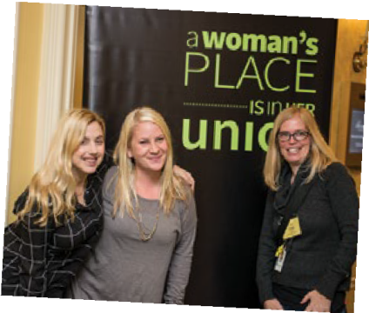
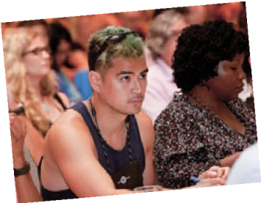
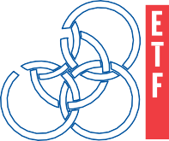

REPORT TO THE
2016 ANNUAL MEETING ON
ETFO’S EQUITY AND WOMEN’S PROGRAMS

A U G U S T 2 0 1 6

ETFO statement and definition of equity
It is the goal of the Elementary Teachers’ Federation of Ontario to work with others to create schools, communities, and a society free from all forms of individual and systemic discrimination. To further this goal, ETFO defines equity as fairness achieved through proactive measures which result in equality, promote diversity and foster respect and dignity for all.
June 23, 2011

ETFO Human Rights Statement

The Elementary Teachers’ Federation of Ontario is committed to:
- providing an environment for members that is free from harassment and discrimination at all provincial and local Federation sponsored activities;
- fostering the goodwill and trust necessary to protect the rights of all individuals within the organization;
- neither tolerating nor condoning behaviour that undermines the dignity or self-esteem of individuals or the integrity of relationships;
and
- promoting mutual respect, understanding and, co-operation as the basis of interaction among all members.

Harassment and discrimination on the basis of a prohibited ground are violations of the Ontario Human Rights Code and are illegal. The
Elementary Teachers’ Federation of Ontario will not tolerate any form of harassment or discrimination, as defined by the Ontario Human Rights Code, at provincial or local Federation sponsored activities.
November 2010

REPORT TO THE 2016 ANNUAL MEETING ON ETFO’S EQUITY AND WOMEN’S PROGRAMS
1
Table of Contents

Foundations for Equity Work in ETFO........................................2

Changing it up in 2015-2016............................................................4

ETFO’s Diverse Membership.............................................................8
Women’s Participation in ETFO.................................................20
ETFO Equity and Women’s Programs, 2015-2016...........25

- Multimedia Resources for Students, Members,
and Communities..............................................................25
II. Leadership Development..........................................28
III. Workshops, Conferences, Symposia and
Professional Learning Communities.......................30
IV. Support for ETFO Locals’ Equity Work..................34
V. Partnerships............................................38

ETFO Support for Community Initiatives.................................40

Appendix A. ETFO Statement on Social Justice and Equity....................41

Appendix B. ETFO Protocol Concerning Members’ Self-Identification..43

Foundations for Equity Work in ETFO

The Elementary Teachers’ Federation of Ontario (ETFO) provides equity and women’s programs in the context of its fundamental constitutional object:

to foster a climate of social justice in Ontario and continue a leadership role in such areas as anti-poverty, non-violence and equity;

and in the spirit of the definition of equity adopted by the ETFO Executive:

It is the goal of the Elementary Teachers’ Federation of Ontario to work with others to create schools, communities and a society free from all forms of individual and systemic discrimination. To further this goal, ETFO defines equity as fairness achieved through proactive measures which result in equality, promote diversity and foster respect and dignity for all. (2011, June)

A comprehensive policy on social justice and equity was adopted by delegates to the 2003 Annual Meeting:

ETFO POLICY ON EQUITY AND SOCIAL JUSTICE
  - That equity be defined as fairness achieved through pro-active measures which result in equality and social justice for all.
  - That discriminatory practices not be accepted within ETFO and that ETFO work proactively to effect change within the Federation, in the education community, and in Canadian and international society by recognizing, accommodating and celebrating differences among people and groups.
  - That the differences among people and groups and the provision of special programs for particular groups, where appropriate, be recognized and accommodated within ETFO.
  - That support for learning, growth, personal identities, professionalism, working conditions and livelihood be included as a part of the ETFO commitment to protect and further the interests of members.
  - That ongoing work in policy development, accountability, professional development, communications, programs and outreach be evidence of the ETFO commitment to equity and social justice.
2014

ETFO’s “Statement on Social Justice and Equity,” approved by the Executive in 2002, is included as Appendix A to this report.
Work incorporating these principles spans all of the service areas of ETFO. The particular issues of women members, Aboriginal members, racialized members, members with disabilities and lesbian, gay, bisexual, transgender, queer or questioning members are addressed through standing committees, included in women’s programs and explored through a range of other equity programs.

WOMEN’S PROGRAMS
In addition to these expressions of ETFO’s commitment to multi-faceted equity issues, there is particular support for women’s participation and leadership in the union. The ETFO Constitution guarantees positions for women on the Executive (five of 14 positions), and that programs for women will be provided, with funding (6% of ETFO’s annual budget) allocated for this purpose.
ETFO’s women’s programs offer direct services to women members through courses, workshops, awards and publications. Funding is also available to establish provincial and local partnerships with other organizations and to support groups that advance the status of women and women’s issues in society.

ETFO CONSTITUTION, ARTICLE X PROVINCIAL ORGANIZATION

Section 4 – Programs for Women
    - There shall be guaranteed programs for women.

    - The Federation shall allocate 6% of the annual budget to programs for women only.

    - The budget for the programs for women shall be approved as part of the regular Federation budget process.
    - The programs for women will provide direct services to women members.

    - The programs for women will provide funds for partnerships with other organizations.

    - The programs for women will include funding for organizations which advance the status of women and women’s issues.
    - The general secretary, in consultation with the Executive, shall ensure the allocation of staff responsible for programs for women.

Changing it up in 2015-2016

Doing equity work is a process of continual learning and constant change. As activists raise awareness about areas of oppression that have been unexplored until now, we learn to address new areas of liberation, as activists and allies. In 2015-2016, ETFO focused on implementing findings from focus groups of racialized members and LGBTQ members and our review of women’s programs, while expanding our understanding and resources relating to FNMI members and issues.

Challenging Oppression Conference WP This leadership training opportunity is for racialized ETFO women members who are committed to becoming involved in their union. The program included an opportunity to listen, discuss and develop strategies to cope with stereotypes and biases within the education sector and to begin the process of building networks and allies within the racialized teachers’ network and the broader teaching community.

Engaging the Aboriginal Learner (Right to Play/ETFO) Resource Workshop
ETFO and Right To Play have developed a primary, junior and intermediate teacher resource that includes information about Aboriginal peoples and history, using engaging, hands-on activities. Four lessons per division focus on an Aboriginal Person, an Issue, a Worldview, and a Place/Time. The resource also includes a section on self-care. The resource
will be available late summer of 2016 and a one-day workshop will be provided for ETFO members in the 2016-2017 school year.

Engaging Aboriginal Families and Community Workshop
This workshop provides members with information on the diversity of Aboriginal peoples and realities. The workshop explores a variety of elements and best practices for creating culturally inclusive classrooms for Aboriginal students, families and community members. ETFO locals can request this 1.5 hour after- school workshop for their members through Equity and Women’s Services.

omen Online Networking Program for FNMI and Racialized Women
This is one of ETFO’s newest programs to engage, support and allow for networking opportunities for members who self-identify and was developed in response to the recommendations of ETFO’s Racialized Members’ Focus Group and LGBTQ Members’ Focus Group. Feedback from both groups revealed that members continue to face
discrimination and certain systemic barriers in their day-to-day experiences within the education system in Ontario. Both reports confirmed that racism
and homophobia continue to be everyday realities confronting members in the workplace.
Since 2013, ETFO staff has increased efforts to implement programs that meet the needs of its diverse member populations. The creation of an online networking site enables female members from designated groups to build systems of support, share experiences, access advice and guidance from those in leadership positions and mentor one another.
Members participated in two face-to-face sessions and three online modules. The modules included discussions and readings to explore leadership roles. Topics discussed in detail were:
    - What role leadership plays in infusing equity issues throughout the formal and informal curriculum.
    - The challenges inherent in assuming leadership roles to promote issues of equity and inclusion.
    - The importance of privilege and identity as part of our knowledge construction.

The online networking site is facilitated by members trained for the role and moderated by ETFO staff. In 2016-2017, the project will be extended to include women members who identify as LGBTQ and/or persons with a disability.

FNMI Statement
ETFO has committed to acknowledging Indigenous peoples and traditional territories by reading this statement at all ETFO provincial events and meetings:

The Elementary Teachers’ Federation of Ontario acknowledges and thanks the First Peoples of this territory and other Indigenous peoples for sharing this land in order for us to continue our work today.

ETFO’s poster with this statement is available through shopETFO and online at http://www.etfo.ca/AboutETFO/ Governance/FNMIstatement/Pages/default.aspx.

Implementation of ETFO’s new Transgender Policy
At the 2015 Annual Meeting, a Transgender Policy was approved by the delegates. Implementation of the policy is multifaceted and ongoing. Some of the highlights include:

Self-Identification re Gender
Staff have researched and consulted with other organizations about terminology for gender. This refers to the gender questions on the member survey, the event management system registration for ETFO events and conferences, member records data collection and other surveys. Up to this point, ETFO has used two terms – female and male. There are numerous different terms used by non-binary individuals to describe their gender. It is important to note that language and terminology will continue to change and evolve over time as it does in relation to other equity and social justice issues. With this
in mind, the organization has decided to adopt the following terminology for choices of gender:
Please indicate your gender: Female m
Male m
What term describes your gender?

This keeps the number of choices to a minimum, while allowing members to use the term that best describes their gender. ETFO will collect the information and analyze responses to see the
frequency of use. At a future point, the organization may wish to revisit the choices used and add more choices for gender.

Suggested Resources for Gender Independent Children/Trans Youth/Adults
This document is posted on the ETFO website under the Advocacy and Action Tab - Social Justice and Equity. There are also three Voice articles on gender independent children/trans youth posted on the same webpage.

Transgender Day of Remembrance – November 20
In the November 12, 2015 eNewsletter, information was provided to members about the Transgender Day of Remembrance and resources were shared. Staff will continue to highlight this date each year.

ETFO Human Resources
ETFO is developing a policy for staff who are
transitioning at work.

ETFO Staff Professional Development
A professional development session will be held for all
staff in the fall of 2016.

Some components of the professional development session will include:
    - Terms/language used to describe gender identity and gender expression – differences between gender and sexual orientation.
    - What is transphobic language and behaviour, discrimination and harassment.
    - Experiences of transgender people – develop an understanding of their experiences.
    - How to make our organization inclusive and safe for transgender people.

6 REPORT TO THE 2016 ANNUAL MEETING ON ETFO’S EQUITY AND WOMEN’S PROGRAMS

Workshop for Members
A workshop on gender and transgender matters for members is under development and will be made available as part of the EWS workshop series in the fall/winter of 2016/2017.

VOICE Magazine
An article will appear in the fall 2016 issue of Voice to raise members’ awareness of the policy and the work being done by the organization around transgender issues.

Pride Toronto 2016
This year marks the first time that ETFO officially
participated in the Trans March.

Support for Locals
Professional Relations Services (PRS) staff are developing guidelines to assist and support members who are transitioning. This work will be shared with local leaders in future programs.

Implementing findings of the review of
ETFO’s Women’s Programs (WP)
Over a two-year period, ETFO conducted an in- depth review of our Women’s Programs from an organizational perspective. All service areas were part of this review, along with member focus groups. Out of the review came the discovery that several opportunities for members were missing. One of these opportunities was a formal mentoring program.
Unions have a longstanding tradition of informal mentoring: tapping someone on the shoulder or encouraging others to become more involved. Such informal mentoring is essential but it also tends
to reinforce existing dynamics of gender and race. Because mentors generally reach out to others of the same gender and racial background, relying on informal mentoring may leave women and racialized members with limited access to mentoring.
Intentional mentoring can help unions thrive, strengthen and transform over time, supporting experienced leaders to offer their knowledge and experience to a broader range of union members. Formal mentoring is more institutionalized than
informal mentoring, with the Union assisting in the training of mentors, setting up the mentoring relationship, developing an ongoing mechanism for supporting the relationship and providing opportunities for face-to-face learning.
A new program has been developed entitled ETFO MentorCoaching Institute for Women. This three- year program brings together mentors and mentees in a long-term relationship format. The first phase of this program involved the training of mentors; the second year will bring together mentors and mentees, and in the third year mentees will choose an area of ETFO to focus on in depth. The Collective Bargaining service area also developed a mentoring program for women in 2015-2016, which will be folded into the MentorCoaching Institute next year.
The under-representation of women in collective bargaining is not a new phenomenon. This year saw the introduction of a new program, Collective Bargaining Issues for Women Part II, offering more advanced training for women members who have already participated in ETFO’s Collective Bargaining Issues for Women Part I.
Another missing opportunity that was discovered through the WP review was in the area of advanced social justice training for women. Although several of our programs focus on social justice from an introductory perspective, many of our members are very active in social justice issues already and would benefit from advanced programming. Out of this,
a new conference entitled From Charity to Justice was developed. This two-day conference focuses on moving participants out of the “helping others”
mindset and into the “transforming our communities” mindset, where justice for all prevails. This can include working with community coalitions, partnering with community groups, working on real change rather than temporary solutions.

Scholarships for FNMI Women Teacher Candidates
Aboriginal women’s post-secondary enrolment and completion rates are significantly lower than those of non-Aboriginal women in Canada. ETFO has decided to encourage and applaud FNMI women intending to pursue post-secondary education, as these women

will be role models for all young girls in elementary schools and leaders within their own communities.
Starting in 2016-2017, ETFO will provide $12,500 scholarships to two universities in Ontario: Brock (South) and Lakehead (North).The scholarships will be to support FNMI women entering their first year of a full time undergraduate degree program.

Terminology shift: From “Disabled” to “Person with a disability”
In December 2015, the ETFO Executive decided to follow a resolution from the 2015 Annual Meeting that ETFO replace the term “disabled” with the term “person with a disability” in all Federation
communications and resources. Beginning in January 2016, the self-identification box on all ETFO event and conference forms reflects the new terminology.

Welcoming Refugee Children and Families
Over the past year, Canada has welcomed thousands of refugees from Syria and other countries. The influx of refugees from Syria has had a particularly strong impact on Canadian communities, given the large numbers that have arrived in a short period of time. These refugees have also arrived in communities that do not necessarily have refugee support systems already in place. While large, urban school boards have welcomed and supported immigrant and refugee students for many years, there are smaller school boards who are ill-equipped to deal with this. ETFO members and locals recognized this issue immediately and turned to ETFO for assistance and support. ETFO developed a workshop for members on welcoming refugee students into our classrooms, with a particular emphasis on Syrian students. Some locals offered this workshop as an after-school opportunity for members, while other locals were able to partner with school boards and offer the workshop as a half-day session. Sixteen workshops were delivered this year, with several already scheduled for the upcoming school year.
Welcoming Refugee Children And Their Families Into Our Schools is a practical and interactive 90-minute workshop with information and strategies to support elementary educators welcoming refugees and other
newcomers into their school communities. Educators learn about creating environments conducive to understanding, acceptance and integration of these students while forging important connections with families.
Topics include: the acculturation process, second language acquisition, using first language as a resource, determining ESL/ELD programming needs and differentiated instruction. Suggested resources to help with the inclusion and success of students are shared.

UPCOMING 2016-2017

First Nations, Métis and Inuit Growth Chart Literacy Prompt Sheets
To support members using the children’s books outlined in the FNMI Growth Chart poster, one-page literacy prompts with activities for each book will
be developed and posted on ETFO’s website for members to access and use.

Infusing Aboriginal Perspectives and Oral Language into Math and Science Workshop (Grade 6-8)
In the fall of 2016, ETFO members will be provided an opportunity to engage in this two-day workshop to immerse themselves in hands-on and oral language- based activities that are inclusive to Aboriginal culture and pedagogies surrounding mathematics and worldview, science and stewardship, and oral tradition.
EQUITY AND WOMEN’S SERVICES
(EWS) STAFF, 2015-2016
Susy Costa
Kelly Hayes Althea Jensen Kalpana Makan
Administrative Assistant
Co-ordinator Administrative Assistant Executive Staff
Rachel Mishenene (.5) Executive Staff
Erin Orida Administrative Assistant
Adam Peer Executive Staff
Nicole Tighe (.5) Administrative Assistant
Carol Zavitz Executive Staff

ETFO invites members to self-identify, on the annual Member Information Survey as well as on registration forms for ETFO events and positions, as belonging to one or more of the following equity-seeking groups:
    - Aboriginal members;
    - Members with a disability;
    - Lesbian, gay, bisexual, transgender, queer or questioning (LGBTQ) members; and
    - Members belonging to racialized groups.

ETFO has identified the following two goals as part of an ongoing, long-range equity implementation plan (see Appendix A, ETFO Statement on Social Justice and Equity):

Accountability: ETFO must develop clear indicators (for example, data on participation of members of equity-seeking groups in ETFO programs, leadership and staff) by which
our progress in equity can be measured, and report regularly on progress to the membership.
ETFO keeps these goals in mind in organizing its programs.
The Annual Meeting has supported the goal of inclusion repeatedly. Delegates to the 2001 Annual Meeting passed the following policy (33.1):
That all appointed or selected groups within or representing ETFO strive to be representative of diversity.

Collecting and reporting the self-identification statistics below is one of the ways in which ETFO holds itself accountable to members for the commitment to social justice and equity.
We have to be cautious in working with these figures. They are based on individuals’ willingness to self- identify. Not all members of a group will always (or ever) self-identify. Self-identification, therefore, is likely to under-represent reality.
For ETFO’s protocol concerning members’ self-
identification, see Appendix B.

An article on self-identification appeared in the Fall 2015 article of ETFO’s Voice, and can be accessed at http://etfovoice.ca/article/self-identification/

8
REPORT TO THE 2016 ANNUAL MEETING ON ETFO’S EQUITY AND WOMEN’S PROGRAMS
ETFO’s Diverse Membership

Outreach: ETFO must continually seek to include, involve and promote members who belong to equity-seeking groups. (ETFO Statement on Social Justice and Equity, April 2002.)

Population of Ontario
2.0% of Ontarians are Aboriginal (2006 census);
15.5% of Ontarians have a disability (2006 federal Participation and Activity Limitation Survey);
An unknown percentage of Ontarians are LGBTQ; 10% is the most commonly quoted figure. A national survey in Canada (2003) found that 1.9% of men and 1.6% of women reported being gay, lesbian or bisexual;
23.0% of Ontarians belong to racialized groups (2006 census).

ETFO Membership
The 2015-2016 ETFO membership survey shows:
0.9% of ETFO members self-identify as Aboriginal;
1.4% of ETFO members self-identify as persons with a disability;
2.0% of ETFO members self-identify as LGBTQ; and
6.2% of ETFO members self-identify as members of racialized groups.

For teacher members:
0.9% self-identify as Aboriginal;
1.5% self-identify as persons with a disability;
2.2% self-identify as LGBTQ; and
6.3% self-identify as members of racialized groups.

For occasional teacher (OT) members:
1.1% self-identify as Aboriginal;
1.0% self-identify as persons with a disability;
1.6% self-identify as LGBTQ; and
7.2% self-identify as members of racialized groups.

For Educational Support Personnel/Professional Support Personnel (ESP/PSP) members:
6.7% self-identify as Aboriginal;
5.0% self-identify as persons with a disability;
5.0% self-identify as LGBTQ; and
5.0% self-identify as members of racialized groups.

For Designated Early Childhood Educator (DECE) members:
2.1% self-identified as Aboriginal;
1.2% self-identified as persons with a disability;
1.8% self-identified as LGBTQ; and
2.9% self-identified as members of racialized groups.

Annual Meeting, August 2015 (829 delegates and alternates)
1% self-identified as Aboriginal;
3% self-identified as persons with a disability;
5% self-identified as LGBTQ; and
10% self-identified as members of racialized groups.

ETFO Executive
Three or fewer of the 14 provincial Executive members self-identified as a person with a disability; and three or fewer self-identified as members of racialized groups. There were no self-identifications in the Aboriginal or LGBTQ categories.

ETFO Local Presidents
Of the presidents of ETFO’s 76 locals for whom we have self-identification information:
- For teacher local presidents, three or fewer self-identified as members of racialized groups.
- For OT local presidents, three or fewer self-identified as persons with a disability, three or fewer self- identified as LGBTQ and three or fewer self-identified as members of racialized groups.
- For ESP/PSP local presidents, three or fewer self-identified as Aboriginal.
- For DECE local presidents, no one self-identified in any category.

ETFO Chief Negotiators
Of the 49 locals for which we have self-identification information about chief negotiators:
- For teacher local chief negotiators, three or fewer self-identified as a person with a disability, and three or fewer self-identified as LGBTQ.
- For OT local chief negotiators, three or fewer self-identified as LGBTQ and three or fewer self-identified
as members of racialized groups.
- For ESP/PSP and DECE local chief negotiators, no one self-identified in any category.

Provincial Staff
Of the 112 people actively working at ETFO’s provincial office:
2% self-identified as Aboriginal;
16% self-identified as persons with a disability;
9% self-identified as LGBTQ; and
27% self-identified as members of racialized groups.
Of the 56 executive/management staff:
2% self-identified as Aboriginal;
9% self-identified as persons with a disability;
13% self-identified as LGBTQ; and
9% self-identified as members of racialized groups.
Of the 56 support staff:
4% self-identified as persons with a disability;
18% self-identified as LGBTQ; and
45% self-identified as members of racialized groups. No one self-identified as Aboriginal.

Representative Council
Of the 445 ETFO local leaders attending the three meetings of Representative Council (October 2013, February and May 2016):
1.0% self-identified as Aboriginal;
2.0% self-identified as persons with a disability;
6.0% self-identified as LGBTQ; and
7.0% self-identified as members of racialized groups.
Standing Committees
Of the 154 members appointed to serve on ETFO Standing Committees in 2015-2016:
4.0% self-identified as Aboriginal;
10.0% self-identified as persons with a disability;
8.0% self-identified as LGBTQ; and
13.0% self-identified as a members of racialized groups.
Summer Academy 2015, July-August 2015 (1,039 participants)
.3% self-identified as Aboriginal;
.4% self-identified as persons with a disability;
1.0% self-identified as LGBTQ; and
7.0% self-identified as members of racialized groups.
Leaders for Tomorrow WP, 2015-2016 (23 participants)
9.0% self-identified as Aboriginal;
22.0% self-identified as persons with a disability;
26.0% self-identified as LGBTQ; and
52.0% self-identified as members of racialized groups.
ETFO Union School, 2015-2016 (31 participants)
3.0% self-identified as Aboriginal;
6.0% self-identified as persons with a disability;
6.0% self-identified as LGBTQ; and
16.0% self-identified as members of racialized groups.
Reflections on Practice WP, 2015-2016 (21 participants)
4.7% self-identified as members of racialized groups. No one self-identified in any other category.

Presidents and Chief Negotiators Meeting, September 2015 (136 participants)
1.0% self-identified as Aboriginal;
2.0% self-identified as persons with a disability;
6.0% self-identified as LGBTQ; and
2.0% self-identified as members of racialized groups.

Leadership Training, September-October 2015 (307 participants)
4% self-identified as Aboriginal;
4% self-identified as persons with a disability;
7% self-identified as LGBTQ; and
7% self-identified as members of racialized groups.

New Presidents’ Training, September 2015 (18 participants)
6% self-identified as Aboriginal;
6% self-identified as LGBTQ; and
6% self-identified as members of racialized groups.
No one self-identified as persons with a disability.

Lobbying Training for Presidents, October 2015 (42 participants)
2% self-identified as Aboriginal;
7% self-identified as persons with a disability;
5% self-identified as LGBTQ; and
24% self-identified as members of racialized groups.

E-Women for Racialized and FNMI Members WP, October 2015 (26 participants)
6% self-identified as Aboriginal; and
100% self-identified as members of a racial minority.
No one self-identified as persons with a disability or LGBTQ.

Creating Pathways to Success, October 2015 (32 participants)
6% self-identified as Aboriginal;
3% self-identified as persons with a disability;
9% self-identified as LGBTQ; and
3% self-identified as members of racialized groups.

Health and Safety Conference, November 2015 (82 participants)
1% self-identified as Aboriginal;
9% self-identified as persons with a disability;
4% self-identified as LGBTQ; and
7% self-identified as members of racialized groups.

Treasurers’ Orientation, November 2015 (18 participants)
13% self-identified as LGBTQ.
No one self-identified in any other category.

Workshop Presenters’ Palette, November/December 2015 (24 participants)
4% self-identified as Aboriginal;
13% self-identified as LGBTQ; and
8% self-identified as members of racialized groups.
No one self-identified as persons with a disability.

An Ounce of Prevention WP, December 2015 (41 participants)
5% self-identified as LGBTQ; and
32% self-identified as members of racialized groups.
No one self-identified as Aboriginal or persons with a disability.

Woman Abuse Affects Our Children WP, Toronto, December 2015 (31 participants)
3% self-identified as Aboriginal;
3% self-identified as LGBTQ; and
66% self-identified as members of racialized groups. No one self-identified as persons with a disability.

Campaign Training for Designated Groups, January 2016 (6 participants)
17% self-identified as Aboriginal;
17% self-identified as persons with a disability;
50% self-identified as LGBTQ; and
50% self-identified as members of racialized groups.

Next Steps – Interview Skills Workshop WP, January 2016 (24 participants)
4% self-identified as LGBTQ; and
75% self-identified as members of racialized groups.
No one self-identified as Aboriginal or persons with a disability.

CB Academy, December 2015, February and May 2016 (54 participants)
7% self-identified as persons with a disability;
11% self-identified as LGBTQ; and
9% self-identified as members of racialized groups. No one self-identified as Aboriginal.

Visions: For Women in their First Five Years of ETFO Membership WP, January – April 2016 (28 participants)
4% self-identified as persons with a disability; and
25% self-identified as members of racialized groups. No one self-identified as Aboriginal or LGBTQ.

Status Chairs’ Training WP, May 2016 (34 participants)
3% self-identified as Aboriginal;
9% self-identified as persons with a disability;
6% self-identified as LGBTQ; and
6% self-identified as members of racialized groups.

… and still we rise WP, February 2016 (397 participants)
2% self-identified as Aboriginal;
3% self-identified as persons with a disability;
3% self-identified as LGBTQ; and
12% self-identified as members of racialized groups.

Leadership Gathering for FNMI, March 2016 (12 participants)
100% self-identified as Aboriginal.
No one self-identified in any other category.

Leadership Gathering for FNMI Women Members WP, March 2016 (21 participants)
100% self-identified as Aboriginal; and
5% self-identified as members of racialized groups.
No one self-identified as persons with a disability or LGBTQ.

Building Inclusive Schools WP, March 2016 (46 participants)
2% self-identified as Aboriginal;
7% self-identified as persons with a disability;
11% self-identified as LGBTQ; and
50% self-identified as members of racialized groups.

Balancing Act WP, March 2016 (66 participants)
12% self-identified as Aboriginal;
9% self-identified as persons with a disability;
6% self-identified as LGBTQ; and
8% self-identified as members of racialized groups.

Collective Bargaining Conference, March 2016 (135 participants)
1% self-identified as Aboriginal;
2% self-identified as persons with a disability;
4% self-identified as LGBTQ; and
4% self-identified as members of racialized groups.

Financial Health and Wealth, April 2016 (85 participants)
5% self-identified as Aboriginal;
1% self-identified as persons with a disability;
2% self-identified as LGBTQ; and
9% self-identified as members of racialized groups.

Beyond the Basics, April 2016 (27 participants)
11% self-identified as Aboriginal;
4% self-identified as persons with a disability;
15% self-identified as LGBTQ; and
11% self-identified as members of racialized groups.

MentorCoaching Institute WP, April/May/June 2016 (18 participants)
17% self-identified as LGBTQ;
28% self-identified as members of racialized groups.
No one self-identified as Aboriginal or persons with a disability.

FNMI Webinars, April 2016 (29 participants)
41% self-identified as Aboriginal;
14% self-identified as LGBTQ; and
7% self-identified as members of racialized groups.
No one self-identified as persons with a disability.

Presidents’ and Chief Negotiators’ Meeting, April 2016 (131 participants)
1% self-identified as Aboriginal;
1% self-identified as persons with a disability;
5% self-identified as LGBTQ; and
4% self-identified as members of racialized groups.

Innovate 2016, April 2016 (128 participants)
4% self-identified as Aboriginal;
2% self-identified as persons with a disability;
2% self-identified as LGBTQ; and
13% self-identified as members of racialized groups.

Aboriginal Community Engagement, April 2016 (19 participants)
5% self-identified as Aboriginal; and
16% self-identified as LGBTQ.
No one self-identified as persons with a disability or members of racialized groups.

Effective Negotiating Skills for Women Leaders WP, April 2016 (16 participants)
1% self-identified as Aboriginal;
13% self-identified as LGBTQ; and
25% self-identified as members of racialized groups. No one self-identified as persons with a disability.

Woman Abuse Affects Our Children WP, Port Elgin, April 2016 (30 participants)
3% self-identified as LGBTQ.
No one self-identified in any other category.

FNMI Member Sharing Circle, April 2016 (14 participants)
100% self-identified as Aboriginal.
No one self-identified in any other category.

Collective Bargaining Conference for Women Part 1 WP, May 2016 (40 participants)
10% self-identified as Aboriginal;
13% self-identified as persons with a disability;
23% self-identified as LGBTQ; and
20% self-identified as members of racialized groups.

Collective Bargaining Conference for Women Part 2 WP, May 2016 (15 participants)
13% self-identified as persons with a disability;
13% self-identified as LGBTQ; and
13% self-identified as members of racialized groups. No one self-identified as Aboriginal.

LEAD (Leading Educators Actively Developing) Conference: Facilitating a Growth Mindset, May 2016 (60 participants)
5% self-identified as Aboriginal;
3% self-identified as persons with a disability;
3% self-identified as LGBTQ; and
8% self-identified as members of racialized groups.

Aboriginal Education Symposium, May 2016 (30 participants)
23% self-identified as Aboriginal;
7% self-identified as persons with a disability;
13% self-identified as LGBTQ; and
13% self-identified as members of racialized groups.

GSA Symposium, May 2016 (24 participants) 4% self-identified as persons with a disability; 25% self-identified as LGBTQ; and
13% self-identified as members of racialized groups. No one self-identified as Aboriginal.

Ounce of Prevention: Keys to Success in ESP/PSP role, May 2016 (15 participants)
7% self-identified as Aboriginal; and
7% self-identified as persons with a disability.
No one self-identified as LGBTQ or members of racialized groups.

Learning Math in the Early Years, May 2016 (117 participants)
1% self-identified as Aboriginal;
3% self-identified as LGBTQ; and
9% self-identified as members of racialized groups.
No one self-identified as persons with a disability.

From Charity to Justice WP, May 2016 (48 participants)
3% self-identified as Aboriginal;
17% self-identified as persons with a disability;
15% self-identified as LGBTQ; and
29% self-identified as members of racialized groups.

E-Women Face to Face for Racialized and FNMI Members WP, May 2016 (8 participants)
100% self-identified as members of racialized groups. No one self-identified in any other category.

Health and Safety Regional Workshop, Kingston, May 2016 (18 participants)
6% self-identified as Aboriginal.
No one self-identified in any other category.

Health and Safety Regional Workshop WP, Thunder Bay, May 2016 (10 participants)
10% self-identified as members of racialized groups. No one self-identified in any other category.

Health and Safety Regional Workshop WP, Sudbury, May 2016 (16 participants)
6% self-identified as persons with a disability; and
6% self-identified as members of racialized groups. No one self-identified as Aboriginal or LGBTQ.

Leading the Way, May & June 2016 (20 participants)
5% self-identified as Aboriginal;
15% self-identified as persons with a disability;
5% self-identified as LGBTQ; and
20% self-identified as members of racialized groups.

Treasurers’ Training, June 2016 (10 participants)
10% self-identified as Aboriginal; and
10% self-identified as LGBTQ.
No one self-identified as persons with a disability or members of racialized groups.

Woman Abuse Affects Our Children WP, Picton, June 2016 (35 participants)
6% self-identified as Aboriginal;
3% self-identified as persons with a disability;
3% self-identified as LGBTQ; and
9% self-identified as members of racialized groups.

ICT Conference WP, June 2016 (128 participants)
1% self-identified as Aboriginal;
2% self-identified as persons with a disability;
1% self-identified as LGBTQ; and
8% self-identified as members of racialized groups.

Presidents’ meeting, June 2016 (89 participants)
2% self-identified as persons with a disability;
6% self-identified as LGBTQ; and
4% self-identified as members of racialized groups. No one self-identified as Aboriginal.

Ontario Membership Annual Meeting
Staff Representative Council Standing Committees Summer Academy 2015
Presidents and Chief Negotiators meetings

Leadership 2015 Health & Safety Conference
CB Academy Collective Bargaining Conference
…and still we rise WP Learning Math in the Early Years
Innovate 2015 ICT Conference WP
Financial Health & Wealth WP

LEAD

Balancing Act WP

0% 5% 10%

% Members from designated groups in ETFO groups/events with over 50 participants
ABORIGINAL
PERSON WITH A DISABILITY

LGBTQ
RACIALIZED

15% 20% 25% 30%

20
REPORT TO THE 2016 ANNUAL MEETING ON ETFO’S EQUITY AND WOMEN’S PROGRAMS
Women’s Participation in ETFO

ETFO records the attendance and participation of men and women at its decision-making meetings and other
activities. The following figures show participation rates for 2015-2016.

Membership
Eighty-one percent of ETFO members in 2015-2016 are women. This proportion has been constant (80%-81%) since the beginning of ETFO.
Among teachers, 81% of members are women; 80% of OT members are women; 96% of ESP/ PSP members are women and 90% of DECE members are women.

Annual Meeting
Overall, 72% of members attending the 2015 Annual Meeting were women.
During information sessions
76% of the speeches/presentations were by women;
17% of those engaging in general discussion were women; and
97% of those responding to questions were women.

During business sessions
61% of those moving or seconding motions were women;
51% of those speaking for or against a motion were women; 50% of those moving or seconding an amendment were women; 42% of those asking questions were women; and
51% of those rising on a point of order were women.

Executive
Ten of the 14 Executive members are women (71%).

Representative Council
Of the participants registered at the meetings of Representative Council in October 2015 and February and May 2016, 61% were women.

Committees of Representative Council
Representative Council elected members to three committees at its October 2015 meeting.
Steering Committee: five of five members elected were women (100%). Selection Committee: one of five members elected were women (20%). Budget Committee: three of five members elected were women (60%).

Of those who spoke at the three meetings of Representative Council in 2015-2016:

During information sessions
67% of the speeches/presentations were by women;
34% of those engaging in general discussion were women; 40% of those responding to questions were women; and 85% of staff contributions were by women.

During business sessions
51% of those moving or seconding motions were women;
44% of those speaking for or against a motion were women; and
38% of those asking questions were women.

ETFO Local Presidents
Overall, 55% of the presidents of ETFO locals are women.
47% of presidents of teacher locals are women;
48% of presidents of occasional teacher locals are women;
100% of presidents of ESP/PSP locals are women; and
90% of presidents of DECE locals are women.

ETFO Chief Negotiators
Overall, 63% of ETFO’s local chief negotiators are women.
67% of teacher local chief negotiators are women;
52% of occasional teacher local chief negotiators are women; and
67% of ESP/PSP/DECE local chief negotiators are women.

Presidents’ and Chief Negotiators’ Meeting, September 2015
67% of the presenters were women;
24% of those with questions were women; and
50% of those answering questions were women.

Presidents’ and Chief Negotiators’ Meeting, November 2015
76% of those speaking from the podium were women;
20% of those speaking from the floor were women.

ETFO Local Executive members
74% of ETFO members who hold local executive positions are women.

ETFO Local Executive release time
61% of local release time is used by women.

ETFO Standing Committees
Of the 223 applications submitted by members to serve on standing committees for 2015-2016, 170 (76%) were from women.
In 2015-2016, 76% of the members who served on provincial standing committees were women.

Photo credit: Adam Peer

ETFO Staff
Overall, 81% of ETFO staff are women.
77% of ETFO executive/management staff are women; and
86% of ETFO support staff are women.

Professional Relations Services Cases
Of members seeking support from ETFO criminal charges (physical or sexual assault), College of Teachers, College of Early Childhood Educators investigations (professional misconduct, competence, incapacity) and civil lawsuits, from September 2015 to June 2016, 51% were women.

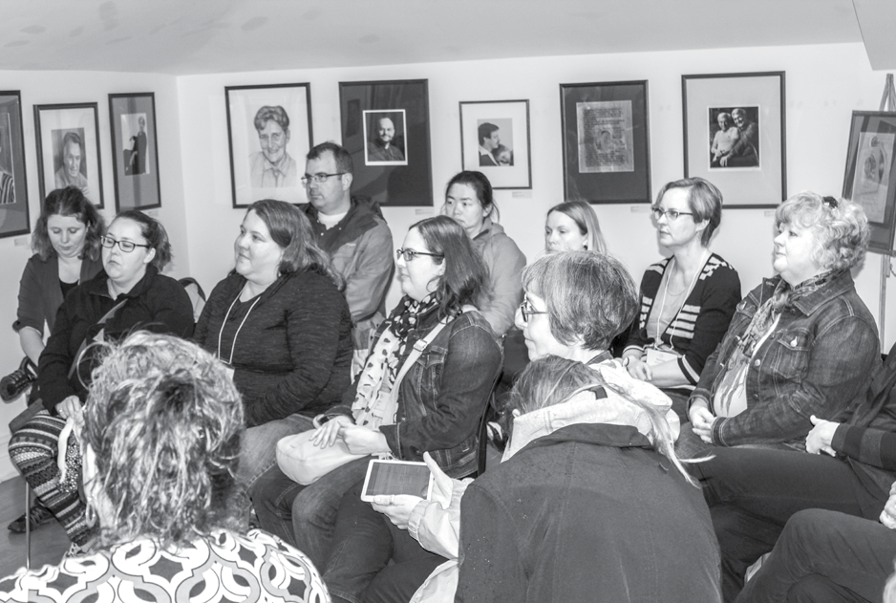
Vibrant GSAs!

Women’s Attendance at ETFO Events and Programs that are Not Women’s Programs

Annual Meeting, August 2015 | 72%
Presidents’ and Chief Negotiators’ meeting, September 2015 | 58%
ETFO Union School, 2015-2016 | 87%
New Presidents’ Training, September 2015 | 67%
Lobbying Training for Presidents, October 2015 | 57%
Creating Pathways to Success, October 2015 | 63%
Health & Safety Conference, November 2015 | 74%
Treasurers’ Orientation, November 2015 | 88%
Presenters’ Palette, November/December 2015 | 96%
CB Academy, December 2015/February/May 2016 | 67%
An Ounce of Prevention, December 2015 | 83%
Campaign Training for Designated Groups, January 2016 | 67%
Leadership Gathering for FNMI, March 2016 | 83%
Collective Bargaining Conference, March 2016 | 50%
Presidents’ and Chief Negotiators’ Meeting, April 2016 | 62%
Aboriginal Community Engagement, April 2016 | 68%
FNMI Webinars, April 2016 | 100%
FNMI Member Sharing Circle, April 2016 | 86%
Innovate 2016, April 2016 | 73%
Financial Health and Wealth, April 2016 | 71%
LEAD – Facilitating a Growth Mindset Conference, May 2016 | 88%
Aboriginal Education Symposium, May 2016 | 77%
GSA Symposium, May 2016 | 79%
Learning Math in the Early Years, May 2016 | 99%
Ounce of Prevention: Keys to Success in the ESP/PSP Role, May 2016 | 100%
Health and Safety Regional Workshop, Kingston, May 2016 | 72%
Leading the Way, May/June 2016 | 71%
Treasurers’ Training, June 2016 | 100%
Presidents’ Meeting, June 2016 | 60%

ETFO NON-WP PROGRAMS RANKED % WOMEN

FNMI Webinars | 100%
Ounce of Prevention: Keys to Success in the ESP/PSP Role | 100%
Treasurers' Training | 100%
Learning Math in the Early Years | 99%
Presenter's Palette | 96%
LEAD | 88%
Treasurers' Orientation | 88%
ETFO Union School | 87%
FNMI Member Sharing Circle | 86%
Leadership Gathering for FNMI | 83%
Ounce of Prevention | 83%
MEMBERSHIP | 81%
GSA Symposium | 79%
Aboriginal Education Symposium | 77%
Health & Safety Conference | 74%
Leading the Way | 71%
Financial Health and Wealth | 71%
Aboriginal Community Engagement | 68%
Campaign Training for Designated Groups | 67%
CB Academy | 67%
New Presidents' Training | 67%
Creating Pathways to Success | 63%
Lobbying Training for Presidents | 57%
Collective Bargaining Conference | 50%
0% 20% 40% 60% 80% 100%

ETFO GOVERNANCE RANKED % WOMEN
MEMBERSHIP
 | 81.00%
Staff | 81.00%
Standing Committees | 76.00%
Local Executive Members | 74.00%
Annual Meeting | 72.00%
Provincial Executive Members | 71.00%
Chief Negotiators | 63.00%
Representative Council | 61.00%
Local Presidents | 55.00%
0% | 20% | 40% | 60% | 80% | 100%

MULTIMEDIA RESOURCES FOR
REPORT TO THE 2016 ANNUAL MEETING ON ETFO’S EQUITY AND WOMEN’S PROGRAMS
25
ETFO Equity and Women’s Programs, 2015-2016
I STUDENTS, MEMBERS, AND
COMMUNITIES

Asian and South Asian Month Brochure The month of May in Ontario is dedicated to celebrating the contributions of Canadians from over 30 countries of the Asian and South Asian diaspora. ETFO’s Asian and South Asian Heritage Month brochure includes a background history of the significant contributions of Asian and South Asian Canadians to Canada as well as classroom and teacher resources, weblinks for books/ publications and websites to help make classroom practice and curriculum more inclusive.

“Beyond Black History Month” Voice
article
In the Spring 2016 issue of ETFO’s member publication Voice, ETFO teacher and author Natasha Henry describes how she is working with teachers to incorporate African Canadian history throughout the year and across curriculum areas including science, history, geography and social studies. The article can be viewed at http://etfovoice.ca/article/beyond-black- history-month/.

Black History Month 2016
This year’s celebration of Black and African Canadians includes the best athletes in the world as well as incredibly successful individuals who have made Canada a better place. ETFO’s poster Canada’s Diverse Athletes—Past and Present spans over 100 years and highlights just a few of these legends of Canadian sport.

Data on the Status of Women
Acting on a recommendation from the Status of Women Committee, a short hand-out including current data relevant to the status of women in ETFO, Canada and globally is prepared annually and provided to members at all ETFO programs.

The Every Teacher Project
ETFO has been involved with The Every Teacher Project
from its beginning in 2012 and continues to take part.
This project is currently the largest study of its kind in the world on LGBTQ-inclusive education practices in Canada’s K-12 schools. 3,400 teachers from across Canada participated in the initial online survey and focus groups. The Every Teacher Project on LGBTQ-
Inclusive Education in Canada’s K-12 Schools Final Report was launched in January, 2016 and is available on the ETFO website at www.mbteach.org/library/Archives/ Handbooks/EveryTeacherProject_book_2016.pdf
Among the main findings were:
- The vast majority of educators approve of LGBTQ-inclusive education;
- Educators in Catholic schools are only slightly less likely to approve but much less likely to practice LGBTQ-inclusive education;
- Only 2% of educators cited conflict with
personal religious beliefs as holding them back;
- 18% agreed that educators should be able to
opt out for religious reasons;
- Lack of leadership and resources were among the main reasons given for not teaching in LGBTQ-inclusive ways;
- Two-thirds were aware of educators being harassed for being LGBTQ; and
- Almost all educators rated their school as safe but far fewer rated their school as safe for LGBTQ students.
ETFO is currently involved with the project workgroup that is developing a workshop and toolkit to communicate the findings and the recommendations that need to be carried out in the education sector
by all parties (e.g., school boards, schools, Ministry of Education, unions, etc.) to address the findings of the report.

26

First Nations, Métis and Inuit Growth Chart
To support members using grade-appropriate literature, an FNMI literature growth chart poster was developed. The poster highlights three FNMI children’s books from grades K to 8 with artistically designed themes. Posters can be displayed in classrooms and ordered through shopETFO.

Inspirational FNMI Women in Canada Poster
This year a poster celebrating 21 First Nations, Métis and Inuit women was developed. The women were selected by FNMI women members based on social justice and equity, protection of the environment and Indigenous rights, and for creative art works.

International Day Against Homophobia and Transphobia (IDAHOT) - May 17
The theme for the 2016 IDAHOT was Mental Health and Well Being. Over 130 countries now celebrate this annual day that originally began in 2004. ETFO produced and posted information on our website and in social media about the day, with reference to The Every Teacher Project and some of the findings on
protective structural factors for teacher mental health.

International Day of Persons with Disabilities - December 3
ETFO commemorates the International Day of Persons with Disabilities. An article appeared in the Winter 2015 issue of Voice. Brochures from the Ontario Human Rights Commission--Preventing
discrimination based on mental health and addiction disabilities: An overview for employers; Human rights, mental health and addiction disabilities; and Disability and Human Rights—were distributed to members to coincide with the International Day of Persons with Disabilities on December 3.

LGBTQ Inclusive SchoolPlace Starts Here Video
ETFO’s Strategy for Challenging Homophobia and Championing Safe Workplaces included confidential focus groups with LGBTQ members. Every group mentioned the need for professional development for everyone so a new resource called the LGBTQ Inclusive SchoolPlace Starts Here video was created. This
ground-breaking video depicts the realities of LGBTQ educators and allies in schools. A lot of work has been done to make students feel safe and included
in schools; now we need to continue this work so that our members feel safe and included. The video is a vehicle to spark conversations and ongoing dialogues to make our schools more inclusive and safe for all.
The video consists of six chapters that are approximately 6-8 minutes long. The accompanying resource guide contains Professional Development Learning modules for each chapter. A workshop has been created for this new resource and is available as part of the Equity workshops program.

Truth and Reconciliation: Voice Article
An article on the Truth and Reconciliation Commission (TRC) was published in the Spring 2016 issue of ETFO’s Voice Magazine. The article includes background information on residential schools, the TRC, ideas on what educators can do in terms of reconciliation and resources for member learning.

Women’s History Month Poster
The poster for 2015 is called Canadian Women and Unions: Organizing for Equality. It is a resource
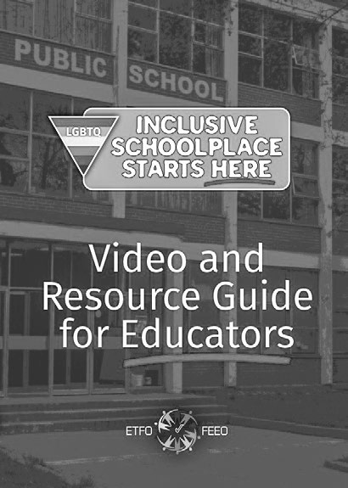
designed to launch discussions about women’s role at

the forefront of the labour movement, in Canada and globally. The poster was developed in partnership with Green Dragon Press and the Ontario Women’s History Network. A list of additional resources is available on ETFO’s website.
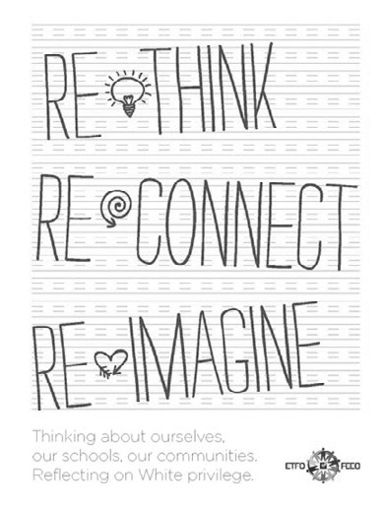

Re-Think, Re-Connect, Re-Imagine. Thinking about ourselves, our schools, our communities. Reflecting on White privilege This new resource on white privilege, anti-racist theory and culturally relevant pedagogy was released at the 2015 Annual Meeting. It raises key questions and makes practical suggestions for educators who want their classrooms, schools and communities to be more inclusive. This year, a writing team of ETFO members have been working together to create
lesson plans to accompany this resource. The existing resource and lesson plans will be made available as an online resource in the fall of 2016.

Voice Women’s Issue
The summer issue of Voice is always a women’s issue, an opportunity to focus on women members, women’s programs and women leaders in ETFO and in the broader community. This year’s issue includes a special feature on the history of women teacher organizing, from the early struggles against discrimination to the fight for pay equity and equal opportunity.
Photo credit: Jill Aoki-Barrett
Also in this issue, Gitksan activist for child welfare, professor and Executive Director of the First Nations Child and Family Caring Society, Cindy Blackstock, reflects on the fight to ensure that First Nations children and families have access to equitable services when compared to the rest of children living in Canada. “Canada cannot meaningfully engage in reconciliation until it stops discriminating against First Nations children,” she states in her discussion with Voice.

Welcome to School
The Welcome to School poster has been reviewed, revised and updated to help ETFO members welcome all students to school, with a more broadly inclusive use of the languages spoken in Ontario homes. This revised poster features the word “welcome” in 32 languages and provides space for students to extend the poster to include the word welcome in any additional language not already represented. A map identifying each language is provided on the reverse side.
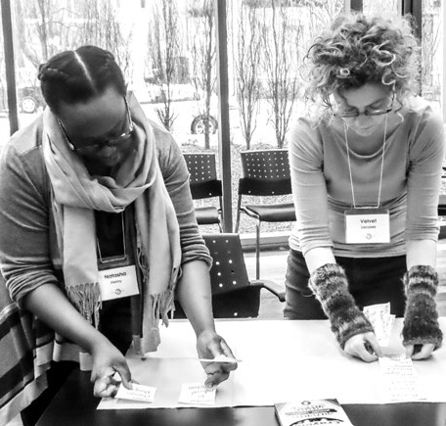
While many of the larger school boards do currently have their own version of a Welcome to School poster, access to such a resource is limited to those larger school boards. The Welcome to School poster is intended to help transition support families transitioning into the public school system, and represents the first face of ETFO in the schools.
Women’s Equality Project WP.

IN DEVELOPMENT:
What have you heard? Confronting Myths about Aboriginal Peoples in Canada
II

LEADERSHIP DEVELOPMENT

Brochure
An online interactive brochure, providing ETFO members with information on Aboriginal peoples in Canada while addressing common misconceptions and statements that are directed towards FNMI people.

Women’s Equality Project WP
Although ETFO offers multiple women’s programs for its members, supports external programs that respond to women’s needs in society and regularly compiles statistics on women’s participation in the union, it has yet to develop curriculum materials that critically look at the broad range of issues affecting women. This multi-year project is designed to fill
this gap and has a dual purpose. The resources will enhance members’ understanding of these issues, be applicable for use with both students in the classroom and as a component of various programs offered to women throughout the union.
This was the first year of the project. A writing team of eight members has been working on four curriculum modules aimed at the junior and intermediate grades, highlighting the issues around women’s equality.
Topics include women and health, violence, social movements and pop culture and the arts.

Beyond the Basics WP
Beyond the Basics 2016 took place over four days at the ETFO Office, involving 27 women from across the province, both released and non-released members of local Executives from DECE, Teacher and OT locals. The program began with a presentation using the Solidarity Skill Set as a way to work through conflict resolution. Workshops included Accommodations, Human Rights, WSIB/LTD, Supporting Members during and after Allegations, Social Media and Privacy as well as the History of Women in The Labour Movement. All workshops included scenarios and role play opportunities as well as time for questions. The final day concluded with a Compassion Fatigue Workshop which left the group energized and with strategies to cope with the demands of the job.

Campaign Training for Designated Groups
This training is intended for members from designated groups committed to seeking election to the provincial ETFO Executive. The course began
with a reflective exercise, examining the participants’ career goals and union involvement now and into the future. The participants were engaged with a general overview of ETFO structure, governance

Photo credit: Daniel Page
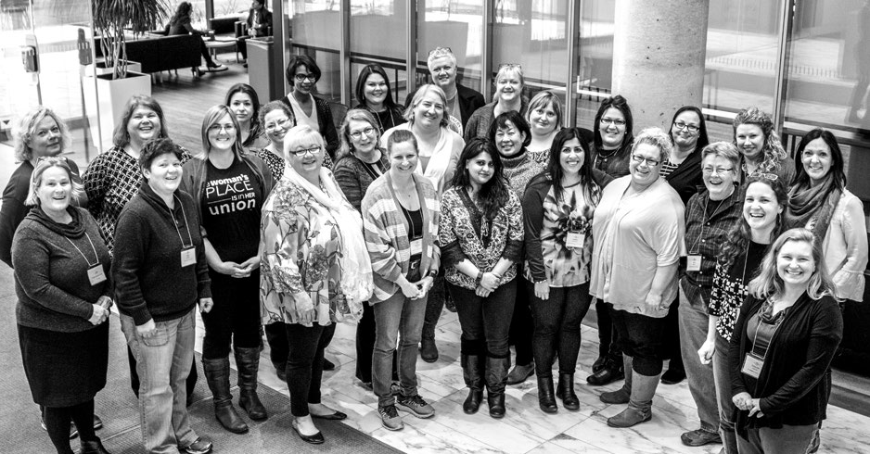
Beyond the Basics WP.

and history: roles of provincial and local Executives, Representative Council, Standing Committees, ETFO staff, constitution and bylaws, policies, priorities and collective bargaining goals. Presentations covered public speaking and how to write an effective speech; the structure and election processes of ETFO’s Annual Meeting; candidates’ guidelines; and expectations of ETFO Executive Members. Members with experience as campaign managers shared their
practical knowledge on what is involved in an election campaign, the types of activities that are undertaken in a campaign, delegating responsibilities amongst the campaign team, the dos and don’ts in an ETFO election campaign and dealing with the inevitable election result, successful or not.
The participants enjoyed the opportunity to watch a video of the speeches from the 2015 Annual Meeting, which helped to inspire them in delivering their own election speech in front of the group. Constructive feedback was then provided to participants on ways to enhance their presentation.

Leaders for Tomorrow WP
Leaders for Tomorrow (L4T) is an intensive, year- long leadership program for women members who self-identify as Aboriginal, persons with a disability, lesbian/bisexual/ transgender/queer/questioning, and/or racialized. The program includes a variety of workshops and experiences related to leadership roles within ETFO both locally and provincially. The course is designed to enhance leadership skills in an inclusive, anti-racist/anti-oppression framework. The program focusses on leadership in the area of equity and social justice, personal and professional development, and union involvement.

Leadership Symposium for FNMI Women Members WP
FNMI women members participated in a two-day workshop to learn about ETFO programs, hear from a panel of FNMI women members active in ETFO and become aware of leadership and professional
development programs available through the Federation.

Reflections on Practice (ROP) WP
Currently in its 12th year, Reflections On Practice: A Women’s Leadership Institute is a professional learning
activity that provides 30 ETFO female members with the opportunity to learn about reflective inquiry, action research, professional activism and leadership. It also provides 10 past participants with the opportunity to facilitate the learning of
their colleagues as they deliver workshops on action research and reflective practice, hone their coaching skills in an online community, improve their team building skills and support the participants as they undertake and complete their action research studies Participants have the opportunity to expand their research skills. The institute was comprised of three sessions: a three-day training session in the summer of 2015; a two-day training session in the fall of 2015; and another two-day training session in the spring
of 2016. The Reflections on Practice Institute recently produced its 9th volume of the Reflections on Practice, A Compilation of Research Reports.

Sisters in the Struggle (SIS) WP
SIS is ETFO’s advanced leadership course for women. This week-long course is designed for women who are already involved in leadership at the local level. Many are graduates of Leaders for Tomorrow or Union School, are members of their local executives and
sit on local and/or provincial standing committees. Several local released officers also attend the course as participants. SIS took place in Port Elgin as an affiliate-specific course during the CLC Women’s School in July 2015.

Visions Program WP
This six-day program is for women in their first five years as ETFO members. Three sessions are held between January and May. Members leave the program with a full understanding of ETFO, including our structure, budget, service areas and Annual Meeting. They learn about labour history, Robert’s Rules, and collective bargaining, meeting many local and provincial leaders and staff on their way.

Workshop Development and Facilitation Training for FNMI Members
FNMI members participated in a two-day training that focused on creating an effective workshop and fostering facilitation skills, while networking. Information on ETFO, programs and professional learning, writing and presentation opportunities were also shared.

III
WORKSHOPS, CONFERENCES, SYMPOSIA AND PROFESSIONAL LEARNING COMMUNITIES
Balancing Act WP
This conference was attended by 73 women ETFO members. Keynote speaker Dr. Pamela Palmater, a Mi’kmaw lawyer from Eel River Bar First Nation,
author, activist and currently Associate Professor and

… and still we rise 2016 WP
ETFO’s Annual Leadership Conference for Women
Four hundred women ETFO members attended
…aswr in February 2016. The keynote speaker was Tony award-winning performer Sarah Jones, who captivated the participants with her multi-character portrayal of equity and social justice issues.
Participants attended workshops focusing on union involvement and leadership. As something new this year, a workshop was offered specifically on The Union and Me: An Aboriginal Perspective. Participants also heard from social justice activist Kim Katrin
Milan and were entertained with the progressive music of Lorraine Segato, lead singer of the band The Parachute Club.
This year, participants were also asked to make a pledge as to how they are going to become
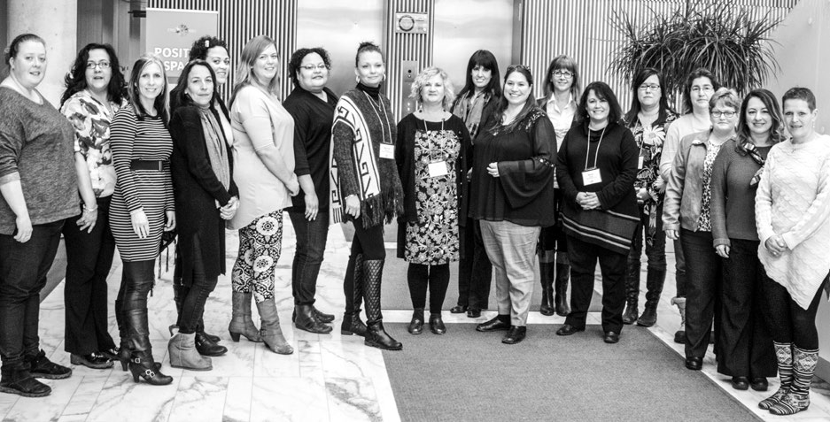
further involved in ETFO once they return to their communities. Women were encouraged to step up to the microphones and share their pledges with the entire group. It was an excellent way for women to use their voices and it allowed the conference to end on a powerful note.
Chair in Indigenous Governance at Ryerson University, discussed the health of FMNI women and girls and the recent federal government announcement to begin an inquiry on the over 1,200 missing and murdered Indigenous women. She also shared her critical analysis “Trudeau’s empty budget promises
on the nation-to-nations relationship.” The link to the article can be found: http://policyoptions.irpp. org/2016/03/23/trudeaus-empty-budget-promises-on- the-nation-to-nation-relationship/.
The following day’s plenary featured a talk about self- care by a certified holistic and functional nutritionist with over 15 years’ experience as an educator, community developer and leadership coach.

Body Image Project
In 2016, ETFO’s Body Image Project website, http:// www.etfo.ca/resources/bodyimageproject/pages/default. aspx was extensively updated with recent research, updated curriculum connections and classroom content. The curriculum documents and supporting resources on this website are organized with the following focuses:
- Grades K to 3: Accepting Diverse Bodies

Photo credit: Daniel Page

- Grades 4 to 6: Promoting Body Acceptance and Building Resistance to Body-based Harassment
- Grades 7 and 8: Questioning Adherence to Body Norms
Throughout the site, there are sample lesson plans from the Reflections of Me grade level curriculum documents, media literacy based lesson plans, research that demonstrates the pervasiveness of body image in all groups in society, links to websites and other resources, Ministry Curriculum references and social justice and equity focused resources that will assist teachers with creating body-positive classrooms.

Building Inclusive Schools, Unions and Spaces WP
This leadership training opportunity for women members focused on various equity issues and provided an opportunity for participants to interact, explore issues, share information and learn strategies to act as a local resource in the promoting anti-racist/ anti-oppression education. Participants attended three workshops: Ontario Human Rights in the Workplace, An Equity-based Approach to Collective Bargaining and From Theory to Practice –Embedding Equity into your teaching practice.

Effective Negotiation Skills for Women
Leaders WP
This program was developed three years ago in partnership with Stitt Feld Handy Group, an
internationally renowned Canadian firm specializing in negotiation and dispute resolution training. The workshop is designed for women who are currently involved in their local and/or at ETFO provincial and aspire to leadership positions in the Federation, particularly in the area of collective bargaining. The members who attended the workshop participated in an interactive format designed to enhance skills required in complex negotiations and dispute resolutions. The workshop also offered participants training in a variety of negotiation styles.

Faculty of Education Equity Workshops In conjunction with ETFO Professional Services, EWS provides Equity workshops for teacher candidates as requested by the Faculties of Education: Poverty,
LGBTQ, Equity, Disabilities/Abilities and White Privilege.

First Nations, Métis and Inuit (FNMI) Online Book Clubs
ETFO has developed two FNMI Online Book Clubs for members: Perspectives and the Truth and Reconciliation Commission and Cultural Connections to Family,
Nature, Nutrition and Games. These professional learning programs provides members a chance to come together to build on their knowledge and understanding of Aboriginal peoples’ diverse
cultural perspectives through the use of children’s books, adult literature and culturally relevant online resources. Members engaged in this welcoming online learning environment will be able to infuse their learning into their classroom practice. One of the book clubs ran in May 2016 and both will be provided to members in the 2016-2017 school year.

FNMI Member Sharing Circle
FNMI members from various geographical areas in Ontario participated in a one-day sharing circle at ETFO. The sharing circle allowed participants to review the 2010 CTF report, “A Study of Aboriginal Teachers’ Professional Knowledge and Experience in Canadian Schools” and share ideas on how ETFO can support Aboriginal members to becoming more involved.

FNMI Education Symposium for ETFO Members
A one-day workshop on culturally relevant teaching, engaging Aboriginal learners, and the Métis education kit was provided to ETFO members. This workshop provided hands-on learning activities, an introduction to FNMI resources, and opportunities to network
and learn from Aboriginal educators and Aboriginal education allies.

From Charity to Justice WP
ETFO’s work with women in our communities is impressive. Members work with sexual assault centres, women’s shelters and women’s organizations. They fill backpacks for children, donate funds, collect donations for shelters and food banks.
Charity work is one pillar of community work. The other pillar is justice/activism.
This new conference was designed to encourage women members who are already active in their communities, particularly women’s communities, to

take the step from charity to justice. It focused on the connections between the union movement and the social justice movement, including historical victories and the differences between charity and justice.
Deirdre Pike, a columnist and activist and Senior Social Planner at the Social Planning and Research Council of Hamilton delivered the keynote address: “Walk with Both Feet.” ETFO staff led a workshop centred on the new Community Outreach Manual for Locals. Other speakers included ETFO members, local leaders and a leader from CUPE Local 4400.

ICT Conference WP
One hundred and fifty women attended this conference, which included presentations on new and innovative practices to leverage technology as a learning tool. Twenty-two women from across the
province facilitated hands-on workshops that provided participants with opportunities to explore tools such as iPads, Google Apps for Education, Web 2.0 and game- based learning. Eighty percent of the participants had never attended an ETFO provincial women’s program before and indicated in their feedback that they enjoyed the learning and networking with other women members from across the province. The conference
was supplemented with funds from the Ministry of Education to allow an extra 25 women to attend.

Next Steps – Résumé Writing and Interview Skills Workshop for FNMI and Racialized Women WP
This two-day program was designed to support racialized and FNMI women members in the area of résumé writing and interview skills preparation. The program was developed to build confidence and provide opportunity for members to build
on these essential skills in a proactive space. On
the first day, participants learned about résumé design and formatting, writing process and job skills requirements. In the computer lab, participants worked in small groups editing and reviewing
the résumés of their peers. On the second day, participants focused on job interview skills. They practiced in small groups, prepared themselves for a mock interview and received feedback on their performances.
This year’s program was attended by members who are pursuing leadership roles within their schools or boards and those pursuing Long Term Occasional (LTO) positions and permanent contract positions.

Photo credit: Adam Peer
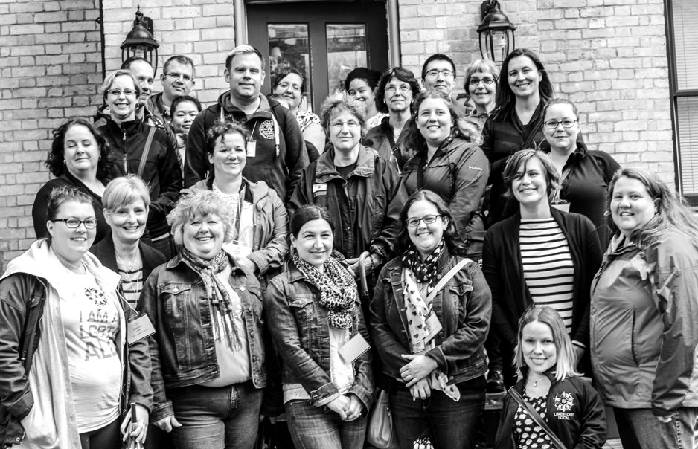

Truth & Reconciliation Webinars for Members
Two webinars were developed and provided for ETFO members on the Truth and Reconciliation Commission. Webinar One – The Truth of Canada’s Legacy provided an historical overview of the Indian Residential Schools in Canada and the impacts from this colonial system on First Nation, Métis and Inuit peoples. Jane Hubbard from the Legacy of Hope (Aboriginal Healing Foundation) was the keynote speaker. Webinar Two - Moving Forward into Reconciliation provided an overview of the Truth and
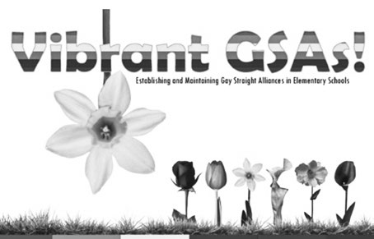
Reconciliation Commission of Canada and the Calls to Action. The intent was to provide ETFO members with information that will support them on their journey in reconciliation. Both one-hour webinars were recorded and are available on ETFO’s webpage.

Vibrant GSAs! (Gay-Straight Alliance) Symposium
Approximately 25 elementary occasional teacher and contract teacher members from across the province attended the symposium this year.
Melissa Sky, a member of the Waterloo Region Occasional Teacher Local and former Public Educator for OK2BME, presented her keynote called “Try to
Be a Rainbow in Someone’s Cloud:” GSA Leaders as Champions. Melissa shared her own learning in helping schools establish and maintain GSAs in Waterloo region, the role and the importance of the GSA leader and how GSAs impact the whole school.
Teachers and students from Allan A. Martin Senior Public School formed the GSA Panel. They shared authentic stories about themselves, why they became involved in the GSA, what their GSA does, who takes part and some of the activities they
have undertaken. After the panel presentation, the participants visited the Canadian Lesbian and Gay Archives (CLGA) for a tour and orientation of services. Participants were appreciative of the resources available to educators and discussed how they
might use the archives for their GSA. Another Story Bookshop was at the office from noon till the end of the day and members were able to purchase picture books and other resources.
On Saturday afternoon, the participants viewed the LGBTQ Inclusive SchoolPlace Starts Here video and engaged in a discussion. Information on The Every Teacher Project was presented and participants spent some time in groups discussing next steps and actions they would be undertaking in the short and long term. Many members commented that their next step was to establish a GSA in their board. For some this would be the first GSA for elementary students in their school board.

Woman Abuse Affects Our Children WP This program focuses on the effects on children of exposure to woman abuse in the home and how educators can help. ETFO held three two-day “train the facilitator” sessions involving approximately 100 members, who are now expected to pass the knowledge along locally and will receive support to do so. One session was held in Toronto, one at the
UNIFOR Family Education Centre in Port Elgin, and the third in Picton.
An online program, Be Aware, Prepare, Educate, provides ETFO members with opportunities to complement and deepen the learning in these face- to-face workshops. A new version, addressing issues of ETFO’s DECE members, is in development.

Women’s Legal Conference – Protect Yourself WP
This conference was attended by 75 women ETFO members. ETFO General Secretary Victoria Réaume was the keynote speaker. The following day featured plenaries on “Women Who’ve Made History” and building union solidarity and participation, and workshops focused on members’ rights and responsibilities.

IV

SUPPORT FOR ETFO LOCALS’ EQUITY WORK
disabilities in their community and society. There was one funded project, providing assistance for particular special needs classes in Lakehead.

Anti-Homophobia and Heterosexism Initiatives Grant
This grant is provided to ETFO locals to assist with the costs of providing training on, awareness of, and/or participation in events that address homophobia and heterosexism. In 2015-2016, 10 locals accessed this funding support.

Day of Pink – April 13, 2016
This year ETFO locals and members celebrated the Day of Pink on April 13 by hosting events at their locals, tweeting messages, selling Day of Pink t-shirts and celebrating the day in their schools. This year’s theme was Take Action on Bullying, Homophobia and Transphobia. ETFO had an extensive Day of Pink webpage with lots of resources and suggestions that members could implement in their schools.

Disability Connections Incentive Funding ETFO supports members in their efforts to increase awareness around disability issues and to educate students on the contributions of people with
Equity and Social Justice Chairs Training – Fall Leadership
This year, local chairs participated in a workshop on member and student mental health issues, common mental health issues, strategies to address mental health in the classroom, our role as educators and use- ful resources. In addition, panelists shared their experi- ences of the work their community has undertaken, what has worked well, what hasn’t and plans and activities for the future. An interactive workshop was presented on the EWS resource called Everyone Is Able. Information was shared about ETFO programs, resour- ces, website highlights and their resource package.

Equity Workshops
Equity and Women’s Services workshops provide equity training to all members, in formats that can be modified for after-school meetings, professional development days or weekend conferences. Fifty equity workshops were delivered in 2015-2016; 32 were sponsored by teacher locals, 15 by OT locals. Three were offered as part of provincial programs.

Photo credit: Daniel Page
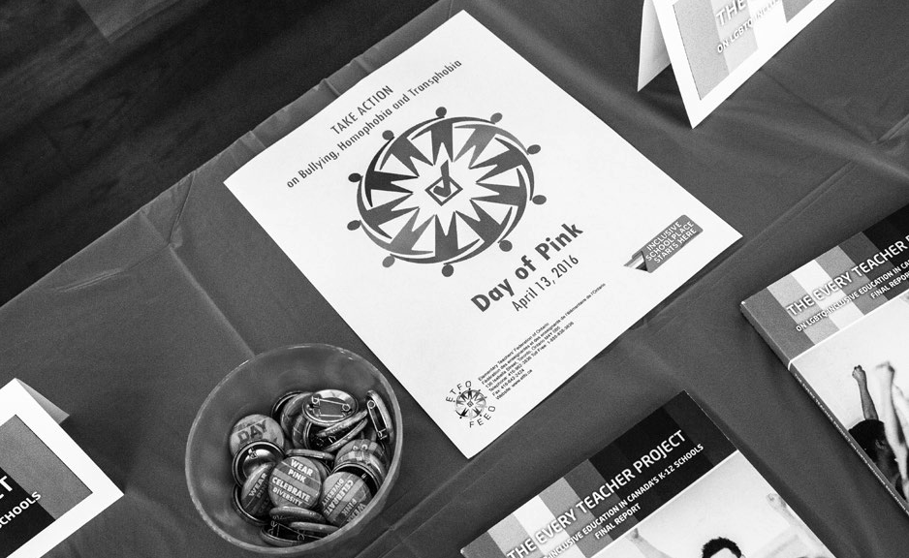

The following Equity Workshops were available in 2015-2016:

Addressing Islamophobia: A Discussion for Educators
This workshop builds awareness of Islamophobia, critically examines personal and professional biases and explores resources to meet the diverse needs of schools.

Deconstructing Stereotypes of Aboriginal People (new)
An exploration of historical and contemporary issues related to Aboriginal people, designed to support un-learning negative attitudes and stereotypes.

Equity 101
An introduction to fundamental ideas and the legal context of equity work.

Everyone is Able.
An introduction to ETFO resources designed to increase sensitivity to and awareness of issues around abilities/disabilities, including curriculum resources for use with students.

LGBTQ Awareness in Primary Classrooms
Even our youngest students may confront issues of homophobia and heterosexism, in relation to
their families and peers as well as to their own gender identities. This workshop is designed to assist educators in exploring these issues and including all children and families in our schools.

LGBTQ Inclusive SchoolPlace Starts Here (new)
An introduction to ETFO’s 40-minute video, featuring interviews with LGBTQ educators discussing the issues they face in the classroom. The accompanying resource guide supports educators and school communities challenging homophobia, heterosexism and transphobia.

Re-Thinking White Privilege
An exploration of white privilege, building awareness and understanding of what educators can do to re-think their own privilege.
Social Justice Begins With Me Designed to help teachers address issues of equity and social justice in their classrooms and assist students in developing awareness and understanding of these issues.
Welcoming and Supporting LGBTQ Families
Participants discuss how to foster positive communication with LGBTQ families, use of inclusive language and curriculum connections.

Photo credit: Adam Peer
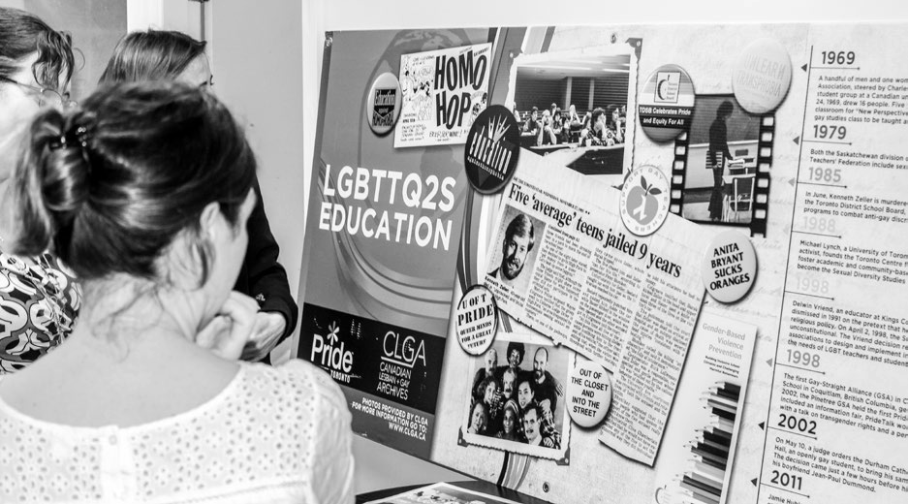
Vibrant GSAs!

Why Poverty? (new)
Examines the impacts of poverty on classrooms and communities, exploring teaching practices and community activism that address the impacts.

Equity Workshop Incentive Funding Equity Workshop Funding provides $300 to up to 20 locals to assist them with costs related to offering equity workshops to members. Twelve locals accessed the funding this year, seven teacher locals and five OT locals.

Health and Safety Training WP
This regional workshop opportunity is designed to support the leadership development of women
members as they build their knowledge and advocacy for safer and healthier workplaces. Regional training workshops for women were held in Thunder Bay
and Sudbury. Participants strengthened their understanding of legal and policy requirements for health and safety through case study and shared experiences. This interactive and informative setting encourages women members to speak with confidence about health and safety issues in their
workplaces and their locals, and to develop a greater interest in this challenging subject during their own leadership development.

International Women’s Day WP
ETFO makes International Women’s Day t-shirts available to locals for use at IWD events. Locals order t-shirts to use as door prizes or to give to members attending a local IWD event. Locals will often partner with community groups to organize an IWD event.

Local Executive Equity Training
Locals regularly hold executive training/planning sessions and request equity training to be part of the program, and staff from Equity and Women’s Services do several of these workshops each year.

Local Incentive Funding WP
This program provides flexible funding to locals for a variety of events and activities related to the status of women. In 2015-2016, 19 locals accessed almost
$45,000 for women’s programs .

“Possibilities”: Addressing Poverty Issues in Elementary Schools
ETFO continues to provide professional learning around one of the most powerful predictors of life outcomes and student achievement: socio-
economic status. “Possibilities” was featured at the OTF Forum Retreat entitled Poverty: Understanding and Reducing Its Impact - What Schools and Teachers Can Do in February 2016. The goal of the retreat/ conference was to assist subject associations in better understanding poverty and its impact on schooling.
Local workshops focus on addressing academic and non-academic needs of students and their families experiencing poverty while addressing assumptions and biases around poverty.
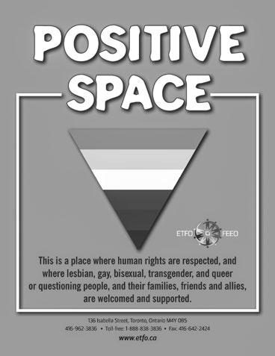

Pride
ETFO celebrated Toronto Pride this year with the theme “Teach Pride!” This theme is a call to action to LGBTQ and allied teachers and also has resonance for LGBTQ and non-LGBTQ students in making school communities safe and welcoming for all people.
ETFO was represented at the evening AIDS Candlelight Vigil. This annual gathering is held to remember and celebrate the lives of those who have died due to complications from AIDS or AIDs-related illnesses. ETFO is a proud sponsor of this event.
ETFO hosted a contingent in the Trans March, Dyke March and Pride Parade. ETFO members also

volunteered at ETFO’s Pride Booth sharing resources developed by ETFO.
Pride events in Ontario were shared in ETFO’s Pride Event poster that went out in a Stewards’ Mailing. Locals were also invited to order free materials, such as the Positive Space brochures, posters, keychains and stickers; I Love GSAs stickers; Some Things We Must Unlearn bookmarks; Welcoming and Supporting LGBT Families brochure; LGBTQ Rights in Your Workplace pamphlets; and other supporting materials.
ETFO’s Online Pride Kit is available on the ETFO website. This resource includes materials and information to assist locals in planning and participating in Pride events. The kit includes: a 2016 Pride Events Flyer; suggestions for other events to celebrate Pride; a sample letter to municipal officials requesting a Pride flag-raising in your community; a “how-to” document dealing with the organization of a booth at a Pride event; downloadable templates that can be used for posters, stickers, buttons, nametags, pennants, t-shirts and other materials designed to insert the name of the local; and information about obtaining other resources.

Spirit Horse
In 2015-2016, ETFO continued to deliver professional development for ETFO members from selected southern Ontario locals who attended the Spirit Horse performance in 2014-2015. The training provided
by ETFO Staff focused on residential schools and reconciliation. Numerous First Nations, Métis and Inuit education resources have been compiled and included in the www.spirithorse.ca website. Funding for the training and professional development for members was provided the Ministry of Education.

Status of Women Chairs Training WP

Leadership 2015
Participants received and reviewed the Status of Women Resources document, shared questions and successes, and learned about incentive and funding programs available for local work. ETFO’s FNMI programs were profiled, as well as the online learning program on woman abuse and its effects on children: Be Aware, Prepare, Educate.

May 2016
Sheila Sampath gave a keynote about working with young women. Women in Action facilitators promoted that program. Members presented their experiences with running for office in ETFO and described a trip
to Chicago that coincided with a teacher strike in that city. Sharing about local programs and events rounded out the day .

Take Back the Night (TBTN) WP
The month of September is typically recognized across Canada and around the world for Take Back

Photo credit: Rachel Mishenene
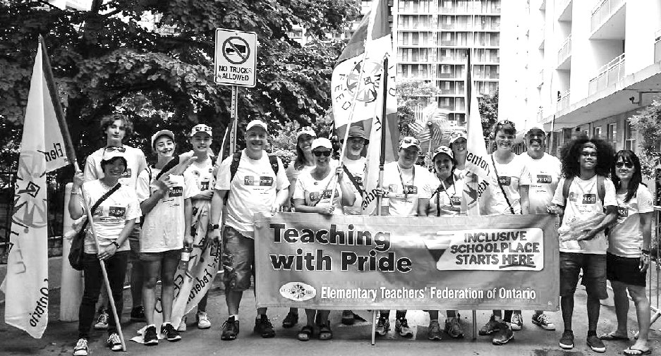

the Night activities. Numerous events are held to raise awareness of the issue of safety for women
and children and to celebrate freedom from violence. Many locals organize TBTN events for local women members and/or work in partnership with other community groups to raise awareness about this critical issue and the importance of working together to end violence against women and girls. ETFO supports locals engaging in TBTN events in their communities.

Women in Action, Levels I and II WP These three-day programs form an introduction to ETFO’s political processes, a call to action for women to become more involved and an opportunity to develop leadership skills such as public speaking and “working a room”. Women members who hold
leadership positions in ETFO facilitate the workshops. In September 2015, a new group of leaders received facilitator training. Seven Women in Action programs were sponsored by locals in 2015-2016, five at Level I and two at Level II.

Working with Equity-Seeking Community Groups WP
This program is a partnership with locals through their Equity Committee(s), focusing on support for women in their community. Up to $2,000 is provided for initiatives with equity and social justice emphasis.
V PARTNERSHIPS
ETFO collaborates with many other organizations that work for social justice. These are some of ETFO’s key partnerships:

The PrideHouse that Kids Built
The PrideHouse Toronto (PHTO) project, of which ETFO was a founding member, was a comprehensive, province-wide engagement and activation strategy for the lesbian, gay, bisexual, transgender, queer or questioning (LGBTQ) communities in Ontario leading up to and during the TORONTO 2015 Pan/Parapan American Games. Its mission was to make these Games the most LGBTQ-inclusive multi-sport games in history. PrideHouse Toronto cast a major footprint and attracted thousands of visitors at various venues:
  - PrideHouse Toronto visitors: 31,000 (including Pavilion, Park, Street Festival).
- The Pride House That Kids Built installation at Ontario’s Celebration Zone: 4,500.
- Social media, Church Street presence, Pride House Ambassadors at Nathan Philips Square: 100,000.
- PrideHouseTO: Sudbury Celebrates! visitors: 350.
- Stories about PrideHouse Toronto appeared in local, national and international media.

Photo credit: Daniel Page
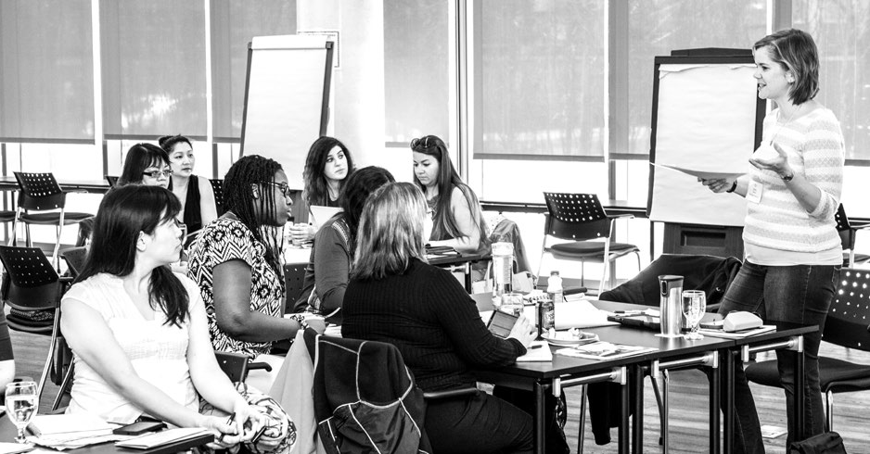
Visions

Developed by ETFO in partnership with PrideHouse Toronto, The PrideHouse That Kids Built included curriculum resources to engage students from Kindergarten to Grade 8 across Ontario to think about why fewer young people are playing sports and the best ways to change assumptions, stereotypes and barriers. Students decorated and returned cardboard ‘bricks’ to ETFO which were used by professional artists Kalpna Patel and Sean Martindale to build a professional art installation.
ETFO secured agreement from the Ontario government to mount the art installation at the Ontario Celebration Zone at Harbourfront Centre. With over 4,500 visitors, government representatives reported that The PrideHouse That Kids Built was the most popular event at the Zone. PrideHouseTO ambassadors were on hand daily to encourage visiting children to create more ‘bricks’ for the installation and engage families in discussion about inclusion. When Premier Wynne had to cancel a visit
to the Zone, government staff rushed to make a video of The PrideHouseThat Kids Built to share with her and other officials. A section of the installation was displayed at ETFO’s Annual Meeting and at the 519 Community Centre during the Pan/Parapan American Games.
The PrideHouse That Kids Built Sudbury was housed at a satellite PrideHouse located at Cambrian College in downtown Sudbury. Supported by ETFO Rainbow locals, 600 cardboard bricks were circulated to children in Rainbow District School Board and
the Better Beginning Better Futures SPOT program. Once decorated bricks were returned, the Laurentian School of Architecture built an art installation. For this and other visitor projects, PrideHouseTO: Sudbury Celebrates! was awarded the Human Resources Award of Excellence from the Ontario Public Service for Excellence in Inclusion, Small Team.
To continue the conversation on the importance of sports inclusion, PrideHouseTO Sudbury Celebrates! has created posters from the bricks.

United Nations Commission on the Status of Women (UNCSW)
ETFO attended the 60th Session of the United Nations Commission on the Status of Women (UNCSW60) in March 2016 in New York City, as part of the Canadian Labour Congress delegation.
The sessions included:
- UN Girls’ Education Initiative, Global Partnership for Education, Plan International Planning for Sustainable Change: Putting Gender at the Heart of the Education 2030 Agenda.
- UNICEF Gender, Education and Peacebuilding: Sustaining Gender Equality through Education.
- Empowering Men and Women to Prevent Violence and Promote Health: Together New Developments in Gender Synchronized Approaches.
- Our Bodies are not Public Property: End Sexual Harassment of Women and Girls in Public Spaces with Advocacy and Partnerships.
- Efforts and Initiatives to End Child Marriages in
Bangladesh.
- Daily debriefing with Canadian negotiators.
- International Trade Unions statement, presented by CLC’s Barb Byers.
- Daily debriefing with CLC and trade union allies.

Springtide Resources: Ending Violence Against Women
ETFO has partnered with Springtide Resources for many years. This partnership has created the Roots of Equality resources, the Woman Abuse Affects Our Children program and, most recently, the online learning program Be Aware, Prepare, Educate, created by Springtide Resources and available free of charge for ETFO members.

White Ribbon Campaign
ETFO in partnership with the White Ribbon Campaign provided support and resources to locals interested in holding the Planting Seeds of Heathy Masculinities
program for grade 6-8 boys, exploring healthy ideas of being a young man. The one-day conference provided a space for boys to discuss issues such as peer pressure, media literacy, violence and gender stereotypes.

ETFO supports many community groups doing equity and social justice work.

Anti-Poverty Groups
In 2015-2016, ETFO made donations totalling $10,000 to grassroots level groups working on poverty issues, undertaking political activities to further their cause or working directly to benefit those living in poverty in their communities.

International Assistance/International Donations WP
ETFO contributed $67,500 and supported projects funded through the Canadian Teachers’ Federation (CTF) Trust Fund Initiatives.
Teachers’ Action for Teaching (TAT)
Teachers’ Action for Teacher Organizations (TATO)
Teachers’ Action for Gender Equity (TAGE)
MATCH International Centre
CODE – Canadian Organization for Development Through Education

Lieutenant Governor’s Aboriginal Literacy Program
ETFO has committed to continue funding this program through 2016 with donations of $35,000 annually.

Overseas Scholarships WP
This year, ETFO provided overseas scholarships totalling $28,500 to the CTF Trust Fund for women teachers in Ghana, Sierra Leone, Togo, Burkina Faso and India; to the Hope for Rwanda’s Children Fund for scholarships for female students; and to the Women’s Wing of Swaziland National Association of Teachers for scholarships for women teachers and female students.

Status of Women Donations WP ETFO allocates $20,000 for Status of Women Donations. These donations are made to organizations whose goals are to improve the
status of women and/or girls in Ontario or Canada. Women’s organizations that received funding this year include:
Canadian Women’s Foundation
Native Women’s Association of Canada
Retired Women Teachers’ of Ontario (RWTO/ OERO)
Willow, Breast & Hereditary Cancer Support
YWCA Canada

Women’s Crisis Centres WP
In 2015-2016, ETFO made donations totalling $60,000 to 77 women’s crisis centres across Ontario.

2015-2016 Women and Girls International Projects WP
This year, ETFO provided financial assistance in
the amount of $160,000 to several international projects working specifically to advance the interests of women and girls overseas. A contribution was made to the Maddox Jolie-Pitt Foundation to assist in the development of a vocational training and literacy centre, and programs for women and girls
in addressing violence prevention, vocational skills development and literacy/educational opportunities for women and girls in Cambodia, and to support the Foundation’s work in Pakistan in constructing schools for girls and assistance for girls accessing education beyond elementary school. Assistance was provided to Education International to further support the re-building of schools and the provision of resources for women and girls in Haiti, including access to education, health services and recovery. A contribution was made to the Fundación Ratón de Biblioteca in Colombia, to strengthen reading and writing skills of women and girls through arts and games generating the taste for use of the English language. Assistance was provided to the Uganda National Teachers’ Union to continue their work in women’s leadership in the union and their on-going campaign to retain young girls in school in Uganda.

40
40
REPORT TO THE 2016 ANNUAL MEETING ON ETFO’S EQUITY AND WOMEN’S PROGRAMS
ETFO Support for Community Initiatives

APPENDIX A
ETFO Statement on Social Justice and Equity

The objects of the Federation shall be:

41
to foster a climate of social justice in Ontario and continue a leadership role in such areas as anti-poverty, non-violence and equity. (ETFO Constitution, Article lll, Objects, 3.4)

A member shall:

strive to eliminate all forms of harassment between individuals in the educational system;
endeavour to ensure equity and inclusiveness in the workplace.
(ETFO Constitution, Article VI, Code of Professional Conduct, 6.1.6-6.1.7)
ETFO recognizes that we live in a society characterized by individual and systemic discrimination against particular groups. Within this context ETFO defines equity as fairness achieved through proactive measures which result in equality for all. (Definition of “equity” adopted by ETFO Executive, October 1999.)
ETFO’s Constitution clearly states its commitment to social justice and equity. In articulating this com- mitment in the following statement, ETFO is acting
from an understanding of itself as an agent for social change.
ETFO is a union committed to protecting and furthering the interests of its members. We see these interests as all-encompassing, not narrowly economic. Teachers and education workers look to their union to support their learning, growth, personal identities, professionalism, working conditions and livelihood.
ETFO is a union whose members, in their work with children in schools can perpetuate the current organization of society or can, by education and
example, foster a positive social transformation. We choose to support each other in learning to change the beliefs, behaviours and systems that damage all of us by excluding and harming some of us.
- ETFO recognizes that discrimination is a fundamental, defining feature of our society, and takes many forms
Discrimination against particular groups of people is one of the central organizing principles by which resources and power are allocated in our society.
Individuals can and do consciously and unconsciously practice discrimination. Discriminatory practices will not be accepted within ETFO. ETFO’s Constitution sets out a complaint and discipline procedure in Article VII: Disciplinary Procedures.
Discrimination is also “systemic,” the result of seemingly neutral policies or practices that, because they are grounded in the understandings of the dominant group, exclude or otherwise disadvantage members of other groups.
ETFO’s members live and work within these discriminatory systems; some benefit from them, some are disadvantaged. As a union committed to social justice and equity, ETFO works actively to change these systems internally, in education and in society.

- Discrimination is experienced differently by different groups, each of which requires support designed to meet its particular needs
Groups that experience discrimination in Ontario
today include:
women;
racialized people;
Aboriginal peoples;
people with disabilities;
gay, lesbian, bisexual, transgender, queer or questioning people; and
people living in poverty.
Members of these groups are in the best position
to identify and analyze the differences in issues

and needs. ETFO commits to recognize and accommodate these differences between people and groups. ETFO will modify programs and
will develop and provide special programs for particular groups where necessary, since in an unequal world, ignoring differences perpetuates inequality.

Growth means change and change is
difficult
Equity work requires planning, commitment and continual reflection. It is multifaceted and, to be effective, involves “walking the talk,” changing the self as well as the world.
It is controversial. Equity work is about fundamental change which is often vigorously resisted. Those who benefit from the way society is currently organized, or who are unaware of the pervasiveness of discrimination, or who are
simply comfortable with the status quo, are often reluctant to contemplate new ways of doing things.
ETFO embraces the need for change and is committed to moving forward on equity and social justice. Members and staff will be supported by ETFO in the learning that is necessary to effect change.

4. ETFO devotes time, staff and other resources to work for social justice and equity at all levels of the organization
ETFO has identified eight goals as part of an
ongoing, long-range equity implementation plan:
Y Policy Development: ETFO’s own policies and practices must be exemplary and as such will support our members’ own equity work as well as positively influencing the policies of other groups.
A belief in equity, supported by organizational structures and expressed in actions are the components of social justice and equity within ETFO.
Accountability: ETFO must develop clear indicators (for example, data on participation of members of equity-seeking groups in ETFO programs, leadership and staff) by which our progress in equity can be measured and report regularly on progress to the membership.
Staff Development and Involvement: ETFO
must have a diverse staff, informed about and
committed to social justice and equity.
Professional Development: ETFO must provide a variety of professional development opportunities and other forms of education in equity to members, staff and provincial and local leadership.
Communications: All ETFO publications must use inclusive language, represent diversity,
recognize special needs and include equity content. ETFO spokespersons must advocate for social justice and equity with members,
governments and the public .
Programs: ETFO must provide programs consistent with its commitment to equity. Programs are needed for member education on issues of social justice and equity, and to support the particular identified needs of members who belong to equity-seeking groups.
Outreach: ETFO must continually seek to include, involve and promote members who
belong to equity-seeking groups. ETFO must build alliances with labour, parents, community groups and other partners to counter discrimination and to advocate for social
justice.
Service Area Development: Equity and Women’s Services provides an operational focus for equity work: identification of equity issues, both internally and externally; making recommendations for action; and monitoring action in all the areas above.

APPENDIX B
ETFO Protocol Concerning Members’
Self-Identification

- Current practice
Self-identification for ETFO members is voluntary and confidential.
Since 2000, ETFO has invited members to self- identify as a member of one of the following designated groups on all application and registration forms:
Aboriginal;
Persons with a disability;
Lesbian, gay, bisexual, transgender, queer or questioning (LGBTQ);
Members of racialized groups; and
Woman.
Members are also invited to self-identify on ETFO’s annual member information survey. Beginning in 2007, members who elect to self-identify on the survey have two options: to self-identify for statis- tical purposes only or for statistical purposes and for outreach (including direct mail) regarding ETFO programs, including leadership programs, focus groups, writing groups, standing committees, etc.

- Personal identity
Many people bear identities that have been imposed upon them by those around them. These identities are often based on stereotypes and can result in social marginalization.
Voluntary self-identification provides individuals with autonomy in defining their identities at a particular time and according to their own criteria. These criteria can include race, gender, sexual orientation, religion, personal history, culture and tradition, and social and political knowledge.
Since identities are multiple and shifting,
the process of self-identification is never straightforward or clear cut. The objective is not to categorize people, but to increase our collective knowledge of the identities of ETFO members in order to meet their needs better.

- Why has ETFO chosen to collect self- identification information only for these particular “designated groups?” With one exception, ETFO’s “designated groups” are the same groups identified in Ontario’s Employment Equity Act (enacted in 1994 and repealed by the Harris government in 1995) and in Canada’s Employment Equity Act (1986, still in effect). The LGBTQ group has been added to ETFO’s “designated groups,” as this group has in recent years been identified by courts throughout Canada as a key equity-seeking group.

These “designated groups” are identified in ETFO’s Statement on Social Justice and Equity, approved by the provincial Executive in 2002 .

Why is ETFO collecting this Information?
ETFO’s constitutional objects and current priorities include commitments to social justice and to member involvement.
Collecting and reporting self-identification statistics is one way ETFO holds itself accountable to members for those commitments.
Members’ self-identification information enables ETFO to reach out to members from equity-seeking groups, to alert them to relevant
programs and to seek their input and assistance in developing inclusive services and programs.
Self-identification helps to ensure that all of ETFO’s policies and practices are inclusive, reflective of our diverse membership and reflect our priorities.

ETFO’s Commitment to Members’ Privacy
The Elementary Teachers’ Federation of Ontario is committed to respecting members’ privacy and protecting members’ personal information.
2007

ETFO PRIORITIES FOR 2015-2016
To protect the collective bargaining rights of all members;
To defend publicly-funded public education;
To serve the needs of the membership;
To provide for the professional development of members;
To promote social justice in the areas of peace, anti-poverty, non-violence and equity;
To support international assistance and co-operation;
To promote the care and protection of the environment;
To actively engage members in the Federation; and
To promote and protect the health and safety of members.

ELEMENTARY TEACHERS’ FEDERATION OF ONTARIO
FÉDÉRATION DES ENSEIGNANTES ET DES ENSEIGNANTS DE L’ÉLÉMENTAIRE DE L’ONTARIO
136 Isabella Street • Toronto, Ontario M4Y 0B5
Phone: 416-962-3836 • Toll free: 1-888-838-3836 • Fax: 416-642-2424
www.etfo.ca

